Exercise 1

Subject Name: Immersive Technology  
  
COURSE CODE:----  
  
  
  
  
  
  
  
  
  
  
  
**Department name**

**Submitted To:                                                                                                    Submitted  By:**

**Karthick B                                                                                         Your name:- Achintya Gaur  
AssociateProfessor                                                                            Roll no :- 1910990740         
(Gaming and Interactive Design Dept)                               Btech.Game Design (2019)**

|  |  |  |  |
| --- | --- | --- | --- |
| S.no | Topics | Page.no | Signature |
| 1 | Basic Marker AR |  |  |
| 2 | Interactive Marker AR |  |  |
| 3 | AR Portfolio |  |  |
|  |  |  |  |
|  |  |  |  |
|  |  |  |  |
|  |  |  |  |
|  |  |  |  |
|  |  |  |  |
|  |  |  |  |
|  |  |  |  |
|  |  |  |  |
|  |  |  |  |
|  |  |  |  |
|  |  |  |  |

**Exercise 1**: Basic Marker AR  
  
**Aim**: To understand the functioning of AR Marker through Vuforio.  
  
**Tools;**

Unity3D – version

Vuforia

---

**Procedure:**

Login

Marker generate

License manager

Target manager

Rating

Installation in unity (mention Vuforia version)

ARCamera

Image target (Database)  
 **Marker:**

Images of the marker

**Output**:



Screen shot 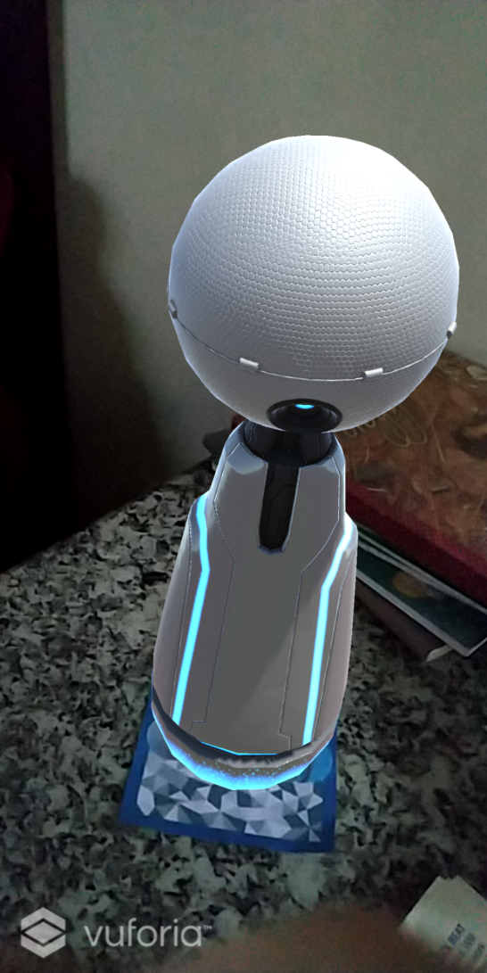

Exercise 2

Subject Name: Immersive Technology  
  
COURSE CODE:----  
  
  
  
  
  
  
  
  
  
  
  
**Department name**

**Submitted To:                                                                                                    Submitted  By:**

**Karthick B                                                                                         Your name:-Achintya Gaur  
AssociateProfessor                                                                            Roll no:-1910990740          
(Gaming and Interactive Design Dept)                               Btech.Game Design (2019)**

|  |  |  |  |
| --- | --- | --- | --- |
| S.no | Topics | Page.no | Signature |
| 1 | Basic Marker AR |  |  |
| 2 | Interactive Marker AR |  |  |
| 3 | AR Portfolio |  |  |
|  |  |  |  |
|  |  |  |  |
|  |  |  |  |
|  |  |  |  |
|  |  |  |  |
|  |  |  |  |
|  |  |  |  |
|  |  |  |  |
|  |  |  |  |
|  |  |  |  |
|  |  |  |  |
|  |  |  |  |

**Exercise 2**: Interactive Marker AR  
  
**Aim**: To understand the functioning of Interactive AR Marker through Vuforio.  
  
**Tools;**

Unity3D – version

Vuforia

---

**Procedure:**

Login

Marker generate

License manager

Target manager

Rating

Installation in unity (mention Vuforia version)

ARCamera

Image target (Database)  
 **Marker:**

Images of the marker



**Output**:

Screen shot 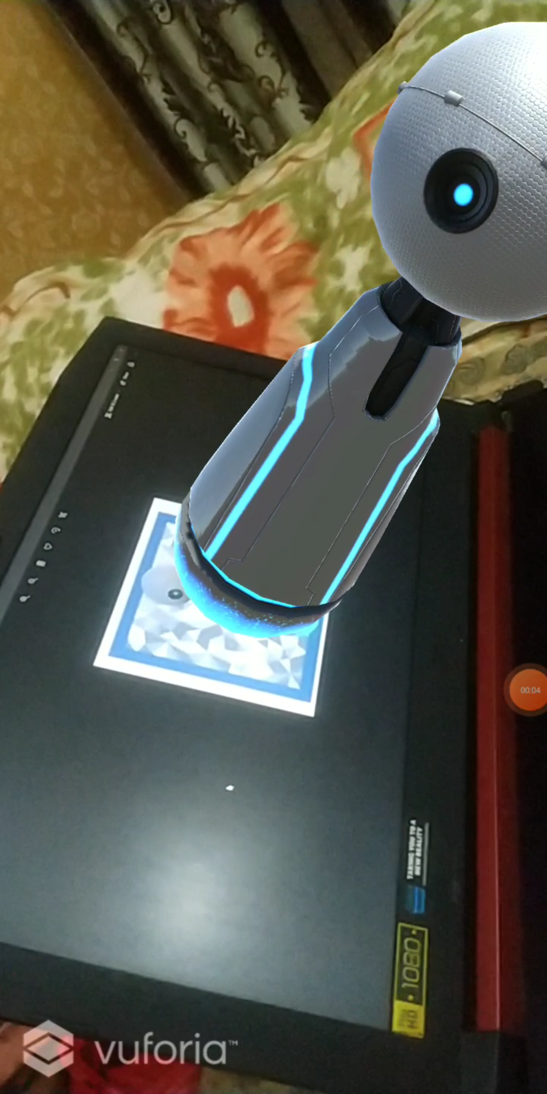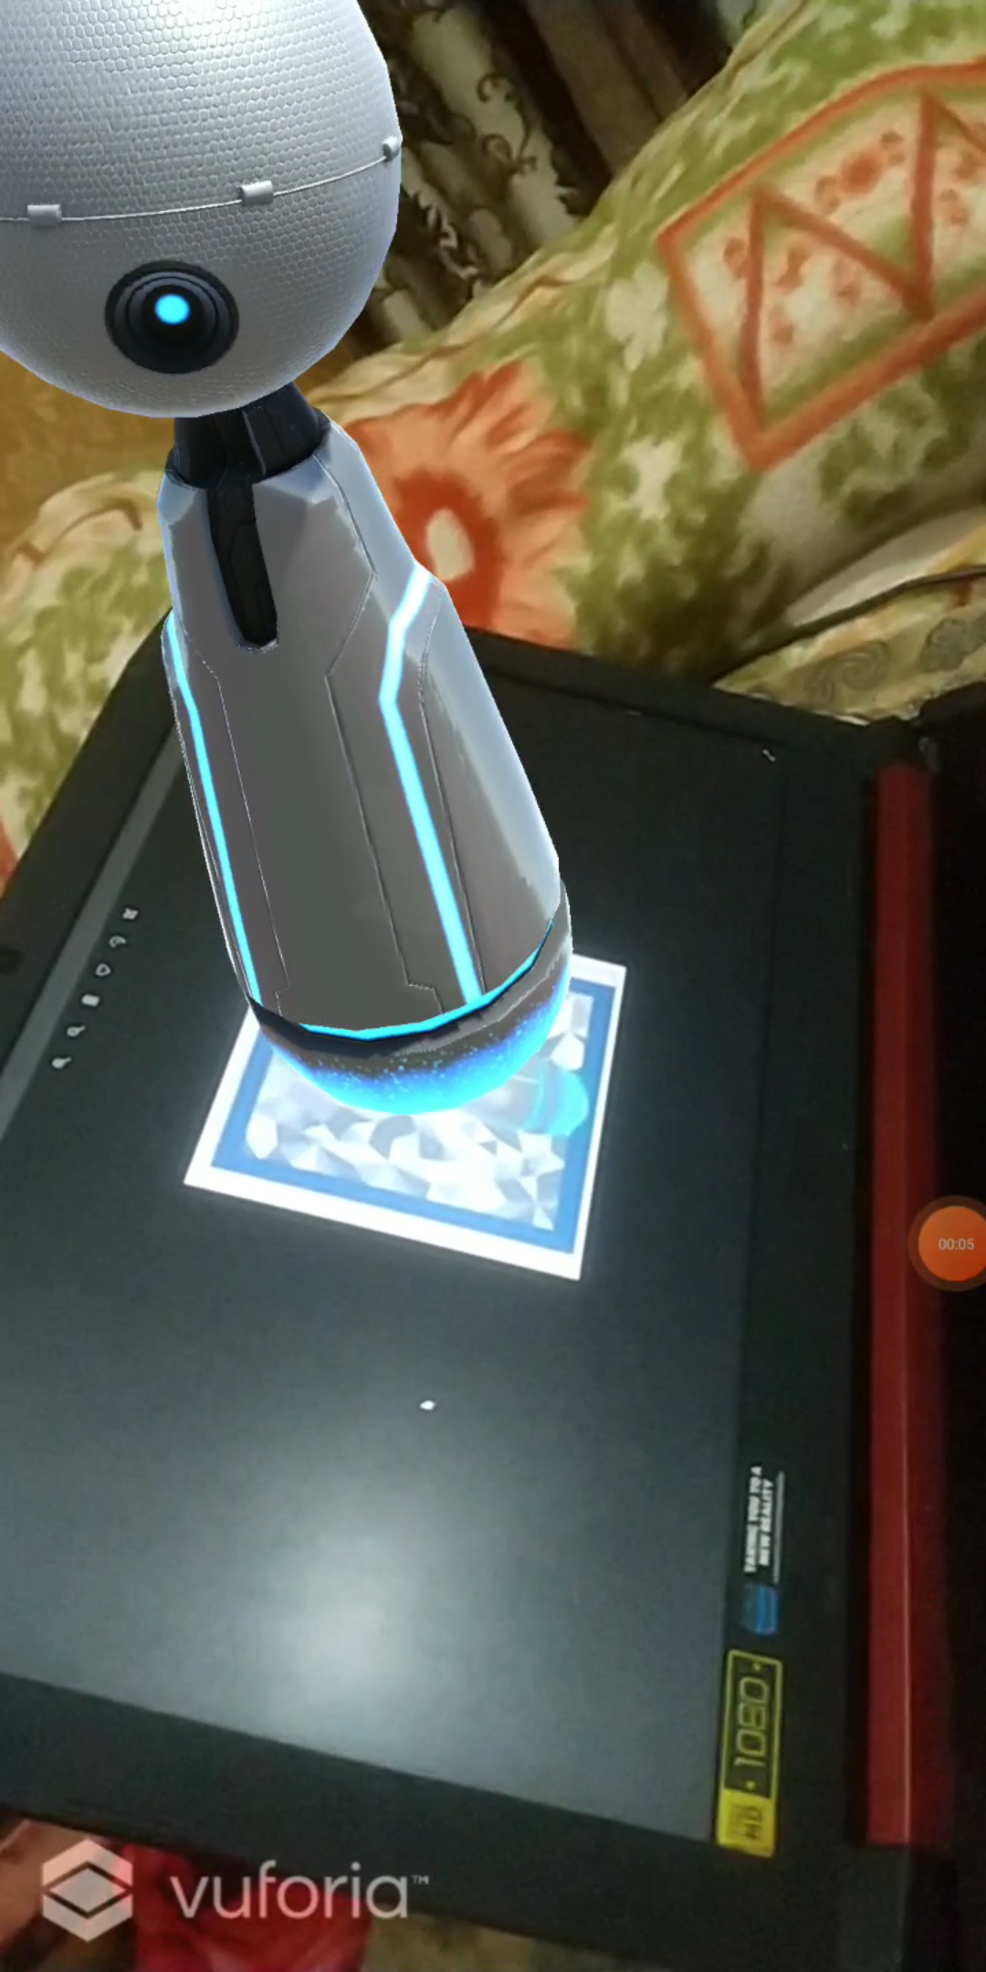

Exercise 3

Subject Name: Immersive Technology  
  
COURSE CODE:----  
  
  
  
  
  
  
  
  
  
  
  
**Department name**

**Submitted To:                                                                                                    Submitted  By:**

**Karthick B                                                                                         Your name:- Achintya Gaur   
AssociateProfessor                                                                            Roll no:- 1910990740          
(Gaming and Interactive Design Dept)                               Btech.Game Design (2019)**

|  |  |  |  |
| --- | --- | --- | --- |
| S.no | Topics | Page.no | Signature |
| 1 | Basic Marker AR |  |  |
| 2 | Interactive Marker AR |  |  |
| 3 | AR Portfolio |  |  |
|  |  |  |  |
|  |  |  |  |
|  |  |  |  |
|  |  |  |  |
|  |  |  |  |
|  |  |  |  |
|  |  |  |  |
|  |  |  |  |
|  |  |  |  |
|  |  |  |  |
|  |  |  |  |
|  |  |  |  |

**Exercise 3**: AR Portfolio  
  
**Aim**: To understand the functioning of AR Marker through Vuforio.  
  
**Tools;**

Unity3D – version

Vuforia

---

**Procedure:**

Login

Marker generate

License manager

Target manager

Rating

Installation in unity (mention Vuforia version)

ARCamera

Image target (Database)  
 **Marker:**



Images of the marker **Output**:

Screen shot 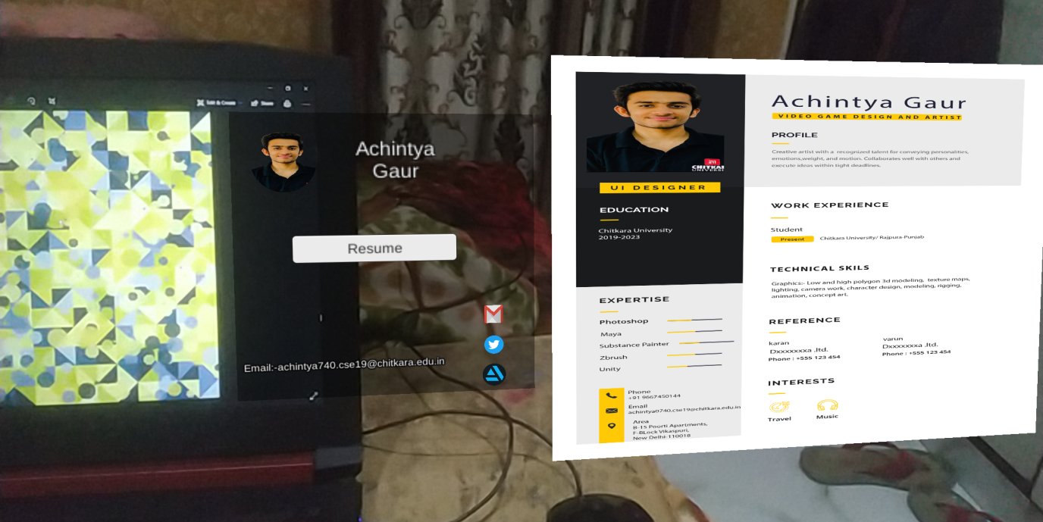

Exercise 4

Subject Name: Immersive Technology  
  
COURSE CODE:----  
  
  
  
  
  
  
  
  
  
  
  
**Department name**

**Submitted To:                                                                                                    Submitted  By:**

**Karthick B                                                                                         Your name:- Achintya Gaur  
AssociateProfessor                                                                            Roll no :- 1910990740         
(Gaming and Interactive Design Dept)                               Btech.Game Design (2019)**

|  |  |  |  |
| --- | --- | --- | --- |
| S.no | Topics | Page.no | Signature |
| 4 | Markerless AR |  |  |
| 5 | Interactive Markerless AR |  |  |
| 6 | FaceMarkerless AR |  |  |
|  |  |  |  |
|  |  |  |  |
|  |  |  |  |
|  |  |  |  |
|  |  |  |  |
|  |  |  |  |
|  |  |  |  |
|  |  |  |  |
|  |  |  |  |
|  |  |  |  |
|  |  |  |  |
|  |  |  |  |

**Exercise 4**: Markerless AR  
  
**Aim**: To understand the functioning of AR Markerless through ARCore.  
  
**Tools;**

Unity3D – version

ARCore

---

**Procedure:**

* Install Plugins from package Manger ( Ar Foundation, Ar Core XR Plugin)
* Got to Player Settings > XR Plugin Management > Android> Enable Ar core
* Add Ar Session Origin, Ar Session, Ar Default Plane to the scene
* Add scripts Ar Session Origin, Ar Raycast Manager, Ar Plane Manager, Ar place Object to Ar Session Origin game object
* Add any model or prefab.
* Place the model or Prefab to the Ar place object script

**Output**:

Screen shot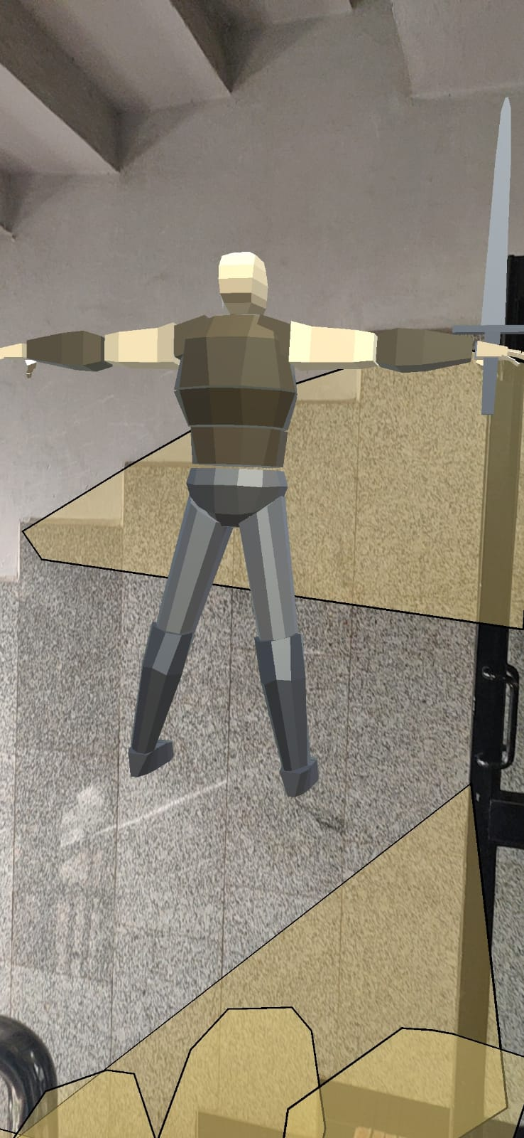

Exercise 5

Subject Name: Immersive Technology  
  
COURSE CODE:----  
  
  
  
  
  
  
  
  
  
  
  
**Department name**

**Submitted To:                                                                                                    Submitted  By:**

**Karthick B                                                                                         Your name:- Achintya Gaur  
AssociateProfessor                                                                            Roll no :- 1910990740         
(Gaming and Interactive Design Dept)                               Btech.Game Design (2019)**

|  |  |  |  |
| --- | --- | --- | --- |
| S.no | Topics | Page.no | Signature |
| 4 | Markerless AR |  |  |
| 5 | Interactive Markerless AR |  |  |
| 6 | FaceMarkerless AR |  |  |
|  |  |  |  |
|  |  |  |  |
|  |  |  |  |
|  |  |  |  |
|  |  |  |  |
|  |  |  |  |
|  |  |  |  |
|  |  |  |  |
|  |  |  |  |
|  |  |  |  |
|  |  |  |  |
|  |  |  |  |

**Exercise 5**: Interactive Markerless AR  
  
**Aim**: To understand the functioning of AR Markerless through ARCore.  
  
**Tools;**

Unity3D – version

ARCore

---

**Procedure:**

* Install Plugins from package Manger ( Ar Foundation, Ar Core XR Plugin)
* Got to Player Settings > XR Plugin Management > Android> Enable Ar core
* Add Ar Session Origin, Ar Session, Ar Default Plane to the scene
* Add scripts Ar Session Origin, Ar Raycast Manager, Ar Plane Manager, Ar place Object to Ar Session Origin game object
* Add any model or prefab.
* Place the model or Prefab to the Ar place object script

**Output**:

Screen shot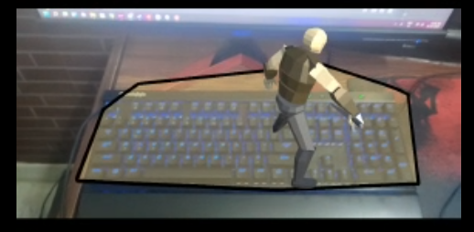

Exercise 6

Subject Name: Immersive Technology  
  
COURSE CODE:----  
  
  
  
  
  
  
  
  
  
  
  
**Department name**

**Submitted To:                                                                                                    Submitted  By:**

**Karthick B                                                                                         Your name:- Achintya Gaur  
AssociateProfessor                                                                            Roll no :- 1910990740         
(Gaming and Interactive Design Dept)                               Btech.Game Design (2019)**

|  |  |  |  |
| --- | --- | --- | --- |
| S.no | Topics | Page.no | Signature |
| 4 | Markerless AR |  |  |
| 5 | Interactive Markerless AR |  |  |
| 6 | FaceMarkerless AR |  |  |
|  |  |  |  |
|  |  |  |  |
|  |  |  |  |
|  |  |  |  |
|  |  |  |  |
|  |  |  |  |
|  |  |  |  |
|  |  |  |  |
|  |  |  |  |
|  |  |  |  |
|  |  |  |  |
|  |  |  |  |

**Exercise 3**: FaceMarkerless AR  
  
**Aim**: To understand the functioning of AR Markerless through Vuforio.  
  
**Tools;**

Unity3D – version

Vuforia

---

**Procedure:**

* Install Plugins from package Manger ( Ar Foundation, Ar Core XR Plugin)
* Got to Player Settings > XR Plugin Management > Android> Enable Ar core
* Add Ar Session Origin, Ar Session, Ar Default Plane to the scene
* Add scripts Ar Session Origin, Ar Raycast Manager, Ar Plane Manager, Ar place Object to Ar Session Origin game object
* Add any model or prefab.
* Place the model or Prefab to the Ar place object script

**Output**:

Screen shot